**Tutorial 5: Phylogeny-based placement of unknown sequences and specimen metadata on a custom reference tree**

In this tutorial, the custom reference tree that was created in Tutorial 3 will be used to illustrate how unknowns can be examined using phylogeny-based placement.

1. Before beginning the tutorial, download these two example files: [Unknowns ITS file1](https://vclv99-239.hpc.ncsu.edu/tbas2_1/pages/data/tbas-tutorial/its_sequences_set1.fasta) and [Unknowns metadata](https://vclv99-239.hpc.ncsu.edu/tbas2_1/pages/data/tbas-tutorial/Metadata-Unknowns.csv). Then go to the [T-BAS start page](https://vclv99-239.hpc.ncsu.edu/tbas2_1/pages/tbas.php) and click on **User Trees**.

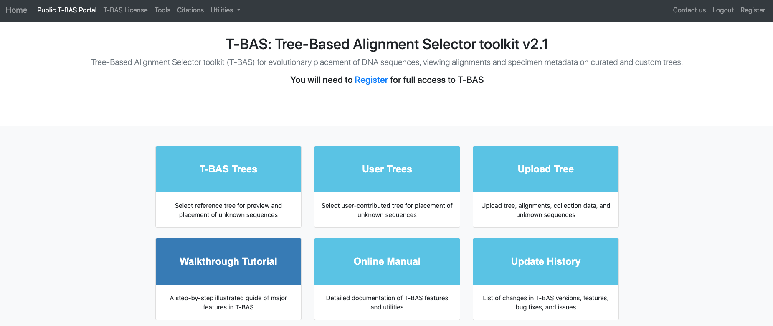

This page will list all of the uploaded user trees. Click on the ***Ramularia* species complex** tree. After clicking on the bullet for ***Ramularia* species complex**, the buttons to **View Metadata** or **Place Unknowns** will be visible. Click on **Place Unknowns**.

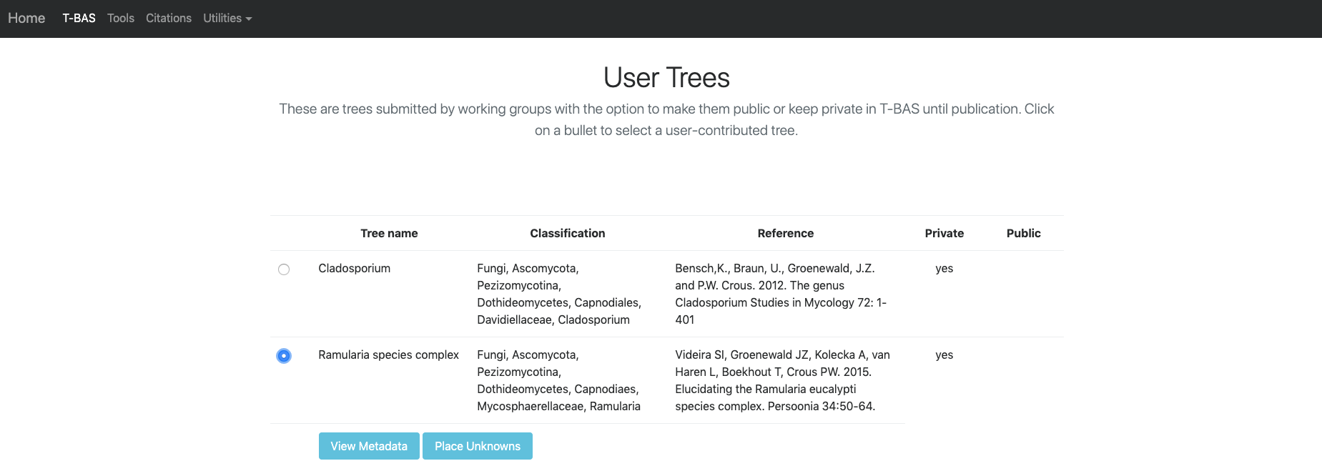

1. Upload the downloaded Unknown ITS file1 Ramularia in the *Upload unknown query sequences* section and the Unknown Metadata Ramularia in the *Upload unknowns metadata (optional)* section. In the BLAST unknown options section, select **ITS locus is included - filter unknowns to selected taxon and generate UNITE report**, Taxon level – **Family**, Taxon name – **Mycosphaerellaceae**. Select **Backbone constraint tree with bootstraps, Multifurcating reference tree with polytomies** and make sure the **Use outgroup** box is checked and leave everything else as default. Click **Submit**.

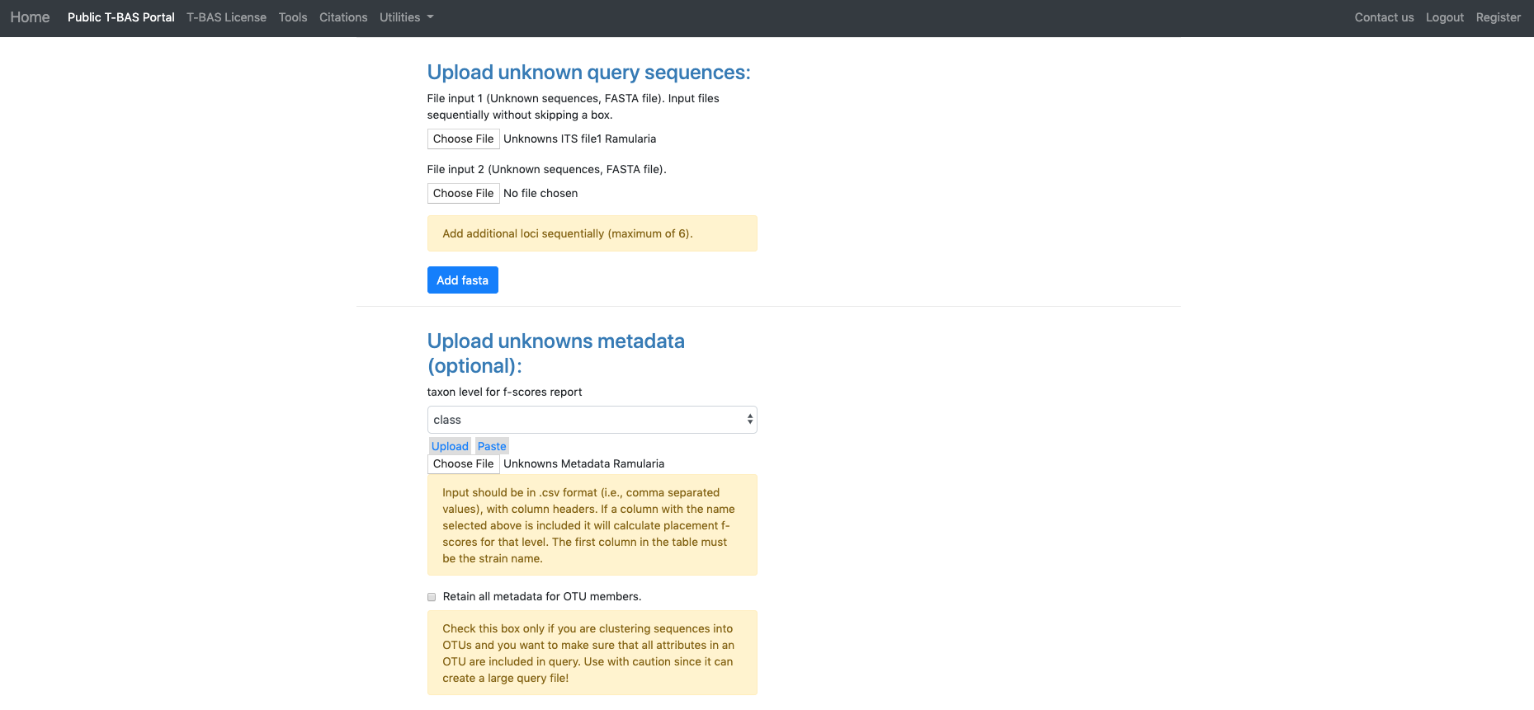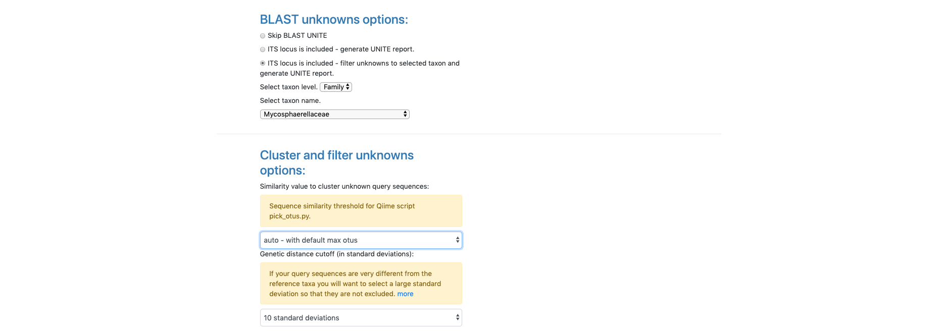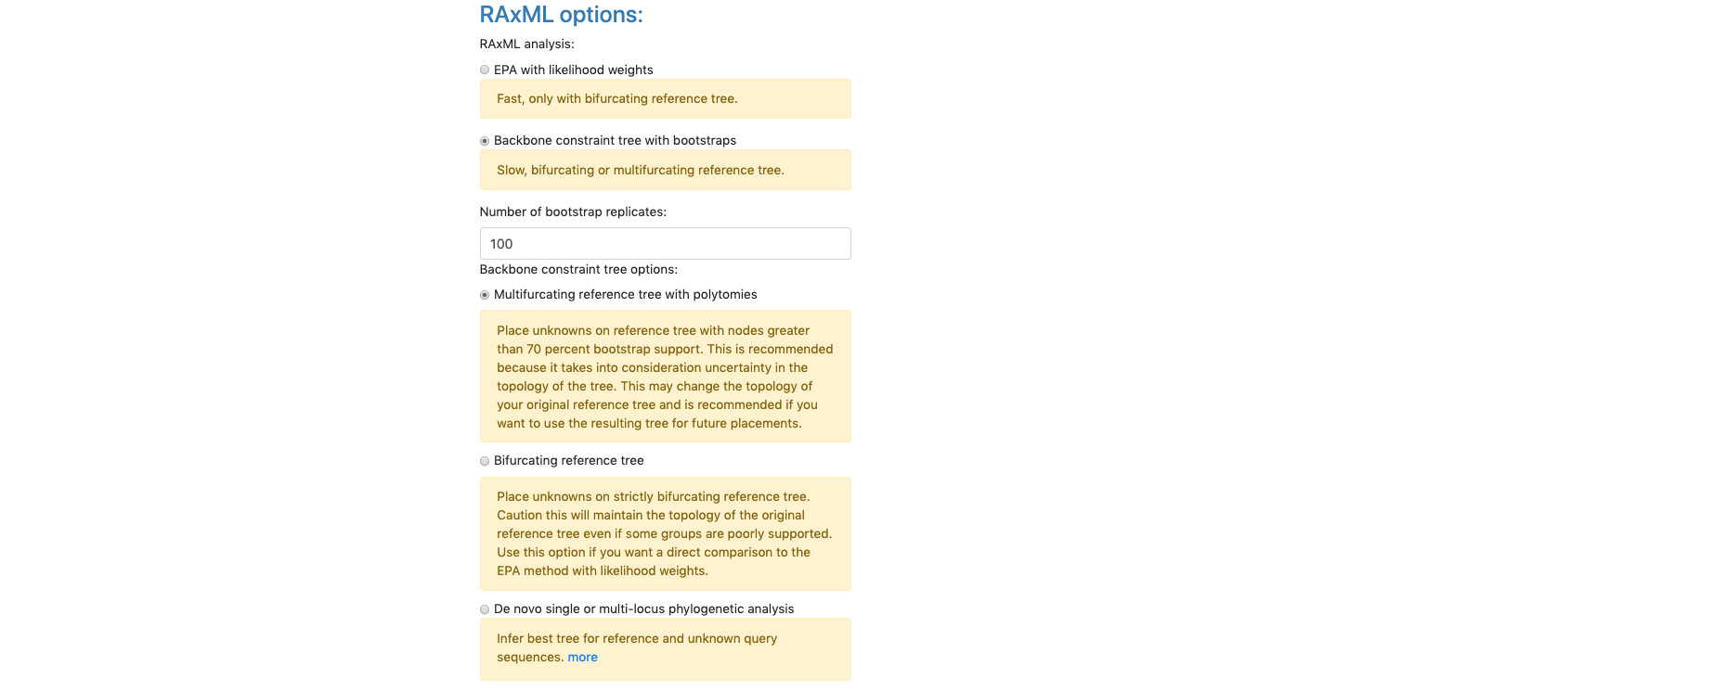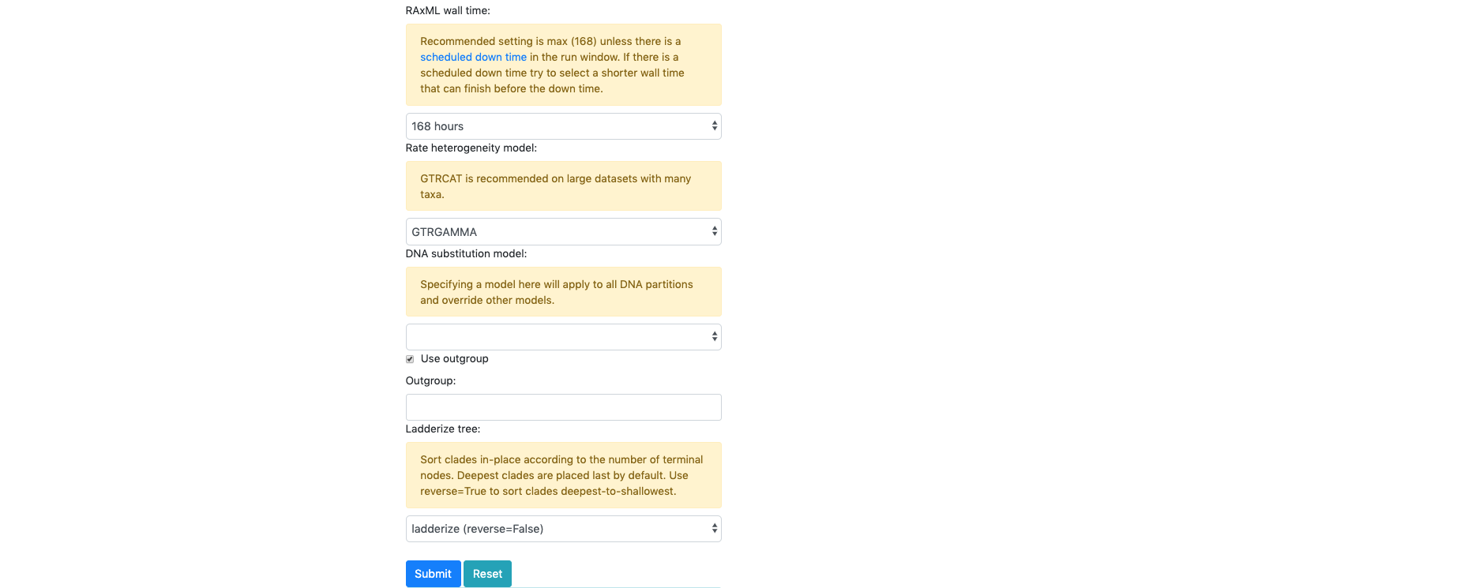

1. A new tab will open showing the selected options for the placement (ensure pop-ups are enabled. If not, enable them and then try again). From the pull-down window select **ITS** and then hit **submit.**

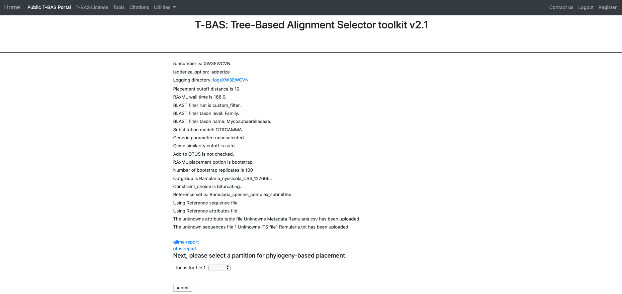

1. Once the run is complete, the results page will look like this. An email will also be sent with the same information. Click on **View Tree**.

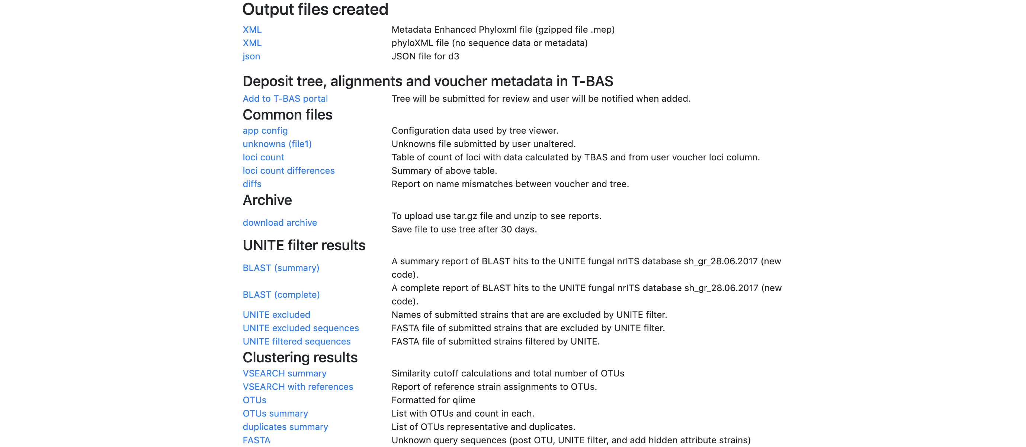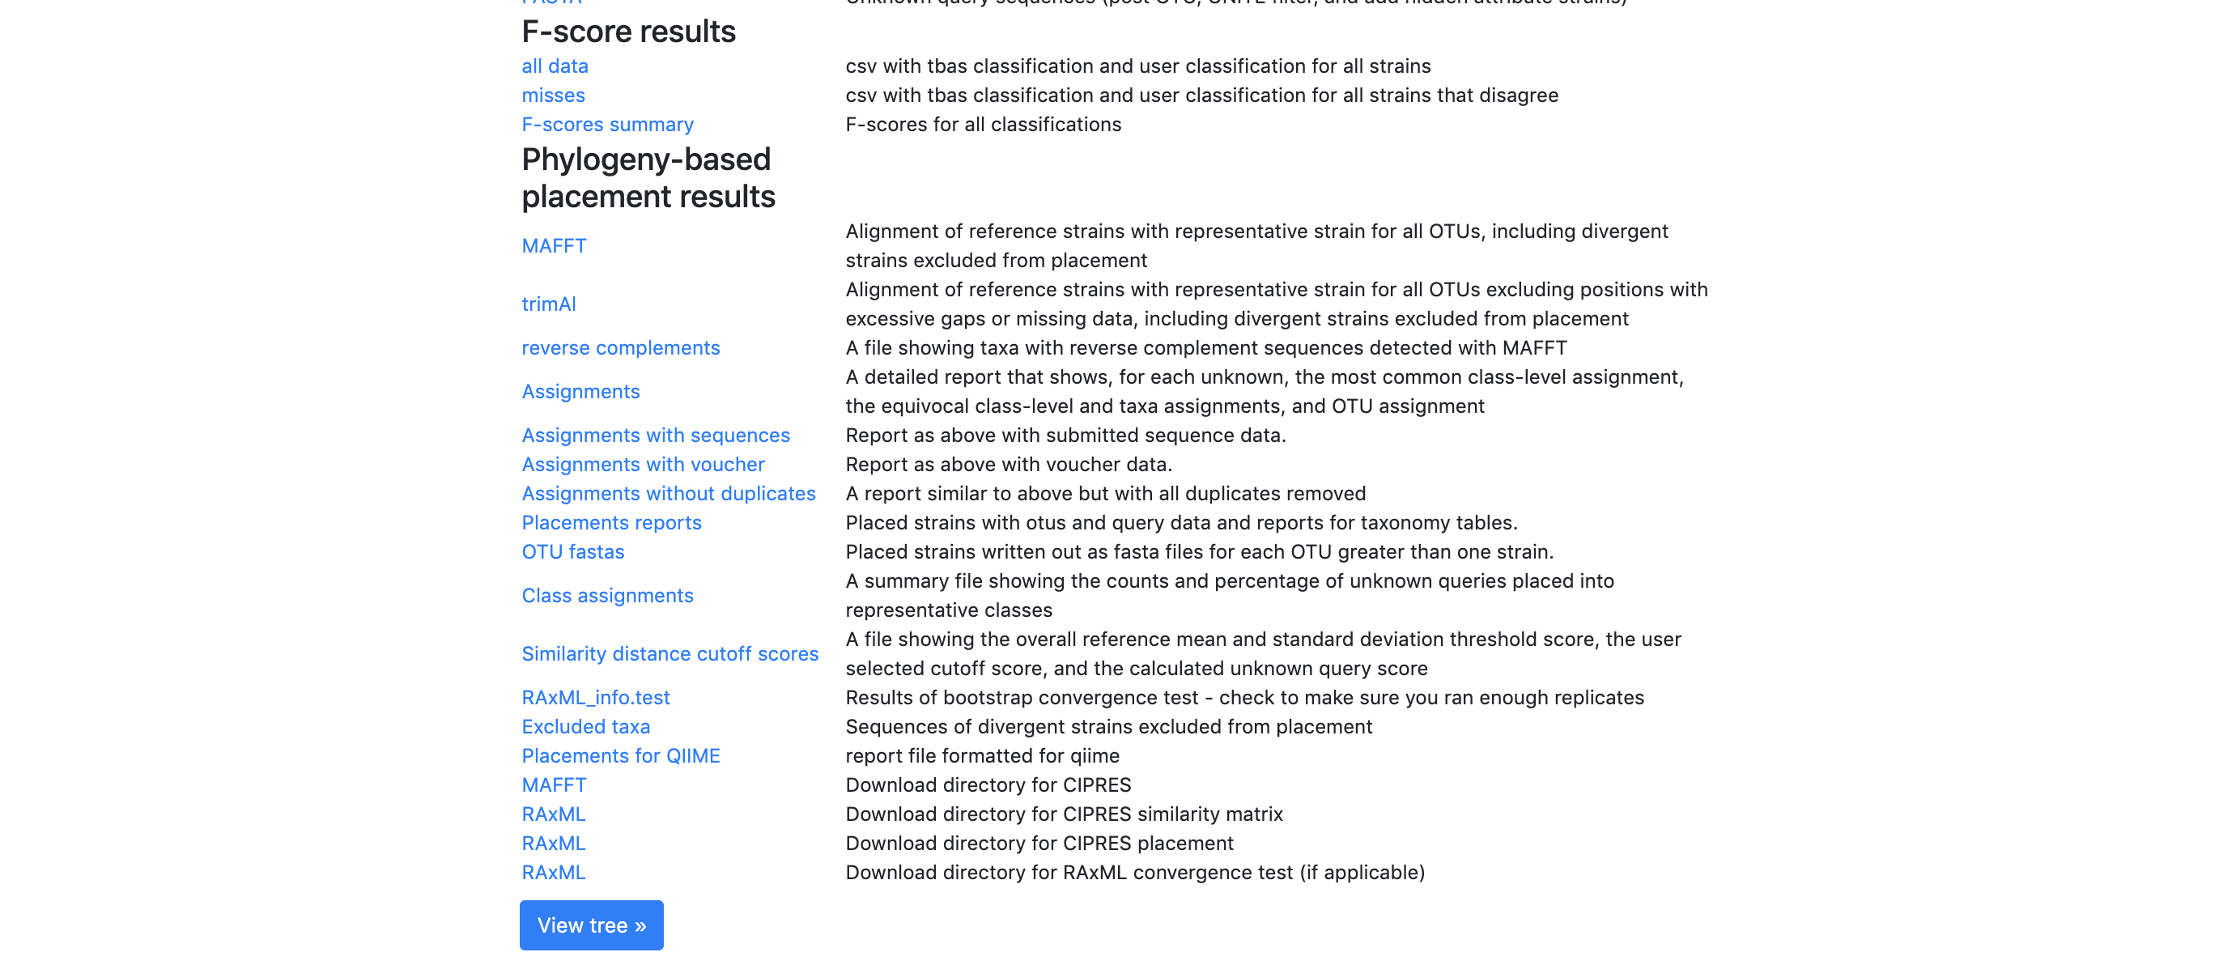

1. Here is the tree with the following options selected:

**Zoom** 0.6260

**Font size** +6

**Font size adjust bootstrap** +6

**Colorize leaves** by Species

Branch **Width** 2

The **branch lengths** are drawn to scale

**Bootstrap values** box is checked.

The legend is displayed in the dashboard window on the right.

All of the unknown sequences are identified as *Ramularia collo-cygni*.

